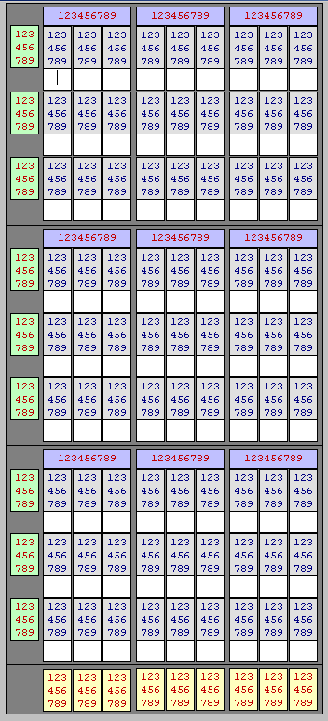

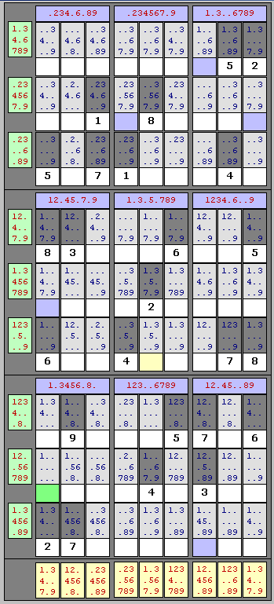

Sudoku Solution Diagram
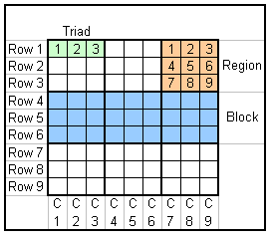

Definitions
Standard Sudoku definitions
Rows - 9 rows, 9 cells per row
Columns - 9 columns, 9 cells per column
Regions - 9 regions, 9 cells per region
LW Additions - used for software solution
Triad - 27 triads, 3 horizontal cells per triad
Block - 3 blocks, 27 cells per block

Quick calc technique
A quick programming technique to determine whether or not each row, each column and each region contains the numbers 1 through 9 would be to add the numbers together. The sum should be 45. (1+ 2 + 3 + 4 + 5+ 6+ 7+ 8 + 9 = 45. If the sum wasn’t 45, then obviously the row or column or region would be invalid. Unfortunately, even if the sum was 45, there is no guarantee that you had each of the numbers 1 through 9 only once. For instance, 8 + 8 + 8 + 7 + 7 + 2 + 2 + 1 + 1 + 1 also equals 45. Obviously this sequence is incorrect. Therefore, in order to quickly determine if each row, column and region contains one and only one of the numbers 1 through 9, each number is converted into a binary as follows: 1=1, 2=2, 3=4, 4=8, 5=16, 6=32, 7=64, 8=128 and 9=256

Step 1 - Triads

